1.BASIC INFORMATION

Vision of the Department :QUALITY EDUCATION wITH HUMAN VALUES

Mission of the Department :EMPOWER THEM TO FACE COMPETITIVE EXAMS

|  |  |
| --- | --- |
| Name of the Department | TAMIL |
| Year of establishment | 1961 |
| Institution Status | Autonomous |
| Groups/Courses related to the Statistics | B.A, B.COM, B.SC |
| New courses introduced during the last five years |  |
| 2f & 12b of UGC |  |
| Website |  |
| Sanctioned posts as per SMPC | 1 |
| No. of Lecturers working (2022-23) | 1 |
| Regular |  |
| Contract |  |
| Guest | 1 |
| Part-time |  |
| Total full time Lecturers working | 1 |
| Department In-charges   1. 2022-23 2. 2021-22 3. 2020-21 4. 2019-20 5. 2018-19 | Dr .R. Alfred |
| Department Area in mts |  |
| Classroom Area in mts |  |
| No. of Digital Classrooms |  |
| No. Virtual Classrooms |  |
|  |  |

**2.ACADEMIC INFORMATION**

|  |  |  |  |  |  |  |  |
| --- | --- | --- | --- | --- | --- | --- | --- |
|  | **Details of the Programmes Offered by the College (Academic years from 2018-2023)** | | | | | | |
| Year | Level of  Programme | Name of Programme/ Course | Duration of Months | Entry Qualification | Medium of  Instruction | Sanctioned  Strength | No. Of Students Admitted |
| 2022-23 |  |  |  |  |  |  |  |
| 2021-22 |  |  |  |  |  |  |  |
| 2020-21 |  |  |  |  |  |  |  |
| 2019-20 |  |  |  |  |  |  |  |
| 2018-19 |  |  |  |  |  |  |  |
| **Total** |  |  |  |  |  |  |  |

3.Teaching Faculty

|  |  |  |  |  |  |  |  |  |
| --- | --- | --- | --- | --- | --- | --- | --- | --- |
| Year | Regular | Contract | Guest | Total | Name of the Lecturers | Transferred from and to | Highest Qualification | Contact information |
| 2022-23 |  |  | 1 |  | i) Dr .R. Alfred |  | M.A;M.Phil;Ph.D |  |
| 2021-22 |  |  | 1 |  | I] Dr .R. Alfred |  | M.A;M.phil;ph.D |  |
| 2020-21 |  |  | 1 |  | i) Dr .R. Alfred |  | M.A;Mphil;ph.D |  |
| 2019-20 | 1 |  |  |  | Dr .R. Alfred |  | M.A;M.phil;ph.D |  |
| 2018-19 | 1 |  |  |  | i) Dr .R. Alfred |  | M.A;M.phil;ph.D |  |

**4.Student details of the department during the last five academic year**

|  |  |  |  |  |  |  |
| --- | --- | --- | --- | --- | --- | --- |
| **Programme** | | **2022-23** | **2021-22** | **2020-21** | **2019-20** | **2018-19** |
| **SC** | **Male** |  | **1** | **1** | **2** | **2** |
| **Female** | **3** | **1** |  | **1** | **1** |
| **Others** |  |  |  |  |  |
| **ST** | **Male** |  |  |  |  | **1** |
| **Female** |  |  |  |  |  |
| **Others** |  |  |  |  |  |
| **OBC** | **Male** | **2** | **2** | **1** | **2** | **2** |
| **Female** |  | **2** | **1** | **1** | **1** |
| **Others** |  |  |  |  |  |
| **General** | **Male** |  | **1** | **1** | **2** | **1** |
| **Female** |  | **1** |  | **1** |  |
| **Others** |  |  |  |  |  |
| **Others** | **Male** |  |  |  |  |  |
| **Female** |  |  |  |  |  |
| **Others** |  |  |  |  |  |
| **Total** |  | **5** | **8** | **4** | **9** | **8** |

**5. Evaluative Report of the Department**

**Name of the Autonomous College………………………………**

**Name of the Department…………**

**Dist.………………………….                      State………………………………..**

**Total Number of Departments in the institution…...............................**

|  |  |  |  |  |
| --- | --- | --- | --- | --- |
| **Sl. No.** | **Name of the Department** | **For Ex: English** | **Zoology** | **Bio-Technology** |
|  | Year of Establishment |  |  |  |
|  | Is the Department part of a School/Faculty of the Autonomous College |  |  |  |
|  | Names of programmes offered |  |  |  |
|  | Number of teaching posts Sanctioned/Filled |  |  |  |
|  | Number of Research Projects:  Total grants received |  |  |  |
|  | Inter –institutional collaborative projects and  Associated grants received | | | |
| National collaboration |  |  |  |
| International collaboration |  |  |  |
|  | Departmental projects funded by DST-FIST, UGC-SAP/CAS,DPE, DBT, ICSSR, AICTE etc., :  Total grants received |  |  |  |
|  | Special research laboratories sponsored by / created by industry or corporate bodies |  |  |  |
|  | Publications: | | | |
| Number of Papers published |  |  |  |
| Number of Books with ISBN |  |  |  |
| Number of Citation Index – range / average |  |  |  |
| Number of Impact Factor – range / average |  |  |  |
| Number of h-index |  |  |  |
|  | Details of patents and income generated |  |  |  |
|  | Areas of consultancy and income generated |  |  |  |
|  | Awards/Recognitions received at the National  and International level by : | | | |
| Faculty |  |  |  |
| Doctoral/Postdoctoral fellows |  |  |  |
| Students |  |  |  |
|  | How many students have cleared Civil Services and Defense Services examinations, NET, SET (SLET), GATE and other competitive examinations |  |  |  |
|  | List of doctoral, post-doctoral students  and research associates | | | |
| From the host institution/university |  |  |  |
| From other institutions/universities |  |  |  |
|  | Number of Research Scholars/ Post Graduate students getting financial assistance from the University/State/ Central |  |  |  |

Note:  ***Compile data for the last five years***

**Declaration by the Head of the Institution**

***I certify that the data included in this Self-Study Report (SSR) are true to the best of my knowledge.***

***This SSR is prepared by the institution after internal discussions, and no part thereof has been outsourced.***

***I am aware that the Peer Team will validate the information provided in this SSR during the peer team visit.***

**Signature of the Head of the institution with seal:**

**Place:**

**Date:**

6. CO, PO and PSO of the Programmes

1:**Relation between stories and society:** The student gained knowledge about therelation between the socio - cultural condition of a society and the short stories through the TAMIL OLDPOERTY where the history of developmentof tamil short stories was discussed in relation with the socio - cultural impact registered in tamil stories in different period

PO 2: Understanding the basis of the classification of tamil literature. Understanding the concept of History of tamil literature.

PO 3: Understanding the importance and basis of the essays **Consciousness about the issues related to women**: The students got scope to gain knowledge and share their ideas about the forms of exploitation faced by women in feudalistic system and also learned about its long drawn effects in society, through the lectures followed by group discussion sessions on women issues, held in the department.

PO 4: Creative writing, Translation will be taught in the Programme and students can chooseprofession like poets, Translators by learning these skills.

**PROGRAMME SPECIFIC OUTCOME**

PSO - 1 Understanding the relation between society and literature and analyse the role played by tamil literature in past and present.

PSO - 2 Developing skill of writing official letters in functional tamil

PSO -3 Developing philosophy of life inspiring by the vision of eminent writers.

PSO -4 Gaining socio cultural consciousness. Exploring, analysing and enriching the self - knowledge.

PSO - 5 The programme will be useful for students to take up further studies and tamil Pandit training.

7. Certificate/Value add-on/MOOCs/Diploma/Online certificate Programmes

|  |  |  |  |  |  |
| --- | --- | --- | --- | --- | --- |
| Year | **2022-23** | **2021-22** | **2020-21** | **2019-20** | **2018-19** |
| No. programmes offered |  |  |  |  |  |
| No. of students Enrolled |  |  |  |  |  |
| No. of students completed |  |  |  |  |  |
| Percentage of students completed against to the total strength |  |  |  |  |  |

8. F***ield projects / research projects / internships during the last five years.***

|  |  |  |  |  |  |
| --- | --- | --- | --- | --- | --- |
| Year | **2022-23** | **2021-22** | **2020-21** | **2019-20** | **2018-19** |
| CSP |  |  |  |  |  |
| No. of students Enrolled |  |  |  |  |  |
| No. of students completed |  |  |  |  |  |
| Percentage of students completed against to the total strength |  |  |  |  |  |

|  |  |  |  |  |  |
| --- | --- | --- | --- | --- | --- |
| Year | **2022-23** | **2021-22** | **2020-21** | **2019-20** | **2018-19** |
| Short term Internship |  |  |  |  |  |
| No. of students Enrolled |  |  |  |  |  |
| No. of students completed |  |  |  |  |  |
| Percentage of students completed against to the total strength |  |  |  |  |  |

|  |  |  |  |  |  |
| --- | --- | --- | --- | --- | --- |
| Year | **2022-23** | **2021-22** | **2020-21** | **2019-20** | **2018-19** |
| Long term Internship |  |  |  |  |  |
| No. of students Enrolled |  |  |  |  |  |
| No. of students completed |  |  |  |  |  |
| Percentage of students completed against to the total strength |  |  |  |  |  |

10. Feedback system : Analysis and Action Taken Report

11.***Enrolment percentage***

Number of seats filled year wise during last five years

(Only first year admissions to be considered)

|  |  |  |  |  |  |
| --- | --- | --- | --- | --- | --- |
| Year | **2022-23** | **2021-22** | **2020-21** | **2019-20** | **2018-19** |
| Number | 5 | 8 | 4 | 9 | 8 |

Number of sanctioned seats year wise during last five years

|  |  |  |  |  |  |
| --- | --- | --- | --- | --- | --- |
| Year | **2022-23** | **2021-22** | **2020-21** | **2019-20** | **2018-19** |
| Sanctioned strength |  |  |  |  |  |
| Admitted strength |  |  |  |  |  |
| Percentage |  |  |  |  |  |

12. Student Centric Methods:

* 1. Experiential Learning
  2. Participative Learning
  3. Problem Solving Learning
  4. ICT enabled tools (usage of online resources)

13.

Mentor and Mentee System:

14.***Percentage of full-time teachers with Ph.D./D.Sc. / D.Litt./ L.L.D during the last five years***

|  |  |  |  |  |  |
| --- | --- | --- | --- | --- | --- |
| Year | **2022-23** | **2021-22** | **2020-21** | **2019-20** | **2018-19** |
| Number |  |  |  |  |  |
| Name of the Lecturers |  |  |  |  |  |
| Year of acquiring Ph.D., |  |  |  |  |  |
| Name of the University |  |  |  |  |  |

15. Grievance and Redressal system

Number of complaints/grievances about evaluation year wise during last five years

|  |  |  |  |  |  |
| --- | --- | --- | --- | --- | --- |
| Year | **2022-23** | **2021-22** | **2020-21** | **2019-20** | **2018-19** |
| Number |  |  |  |  |  |

16. Result Analysis

Pass percentage during the last five years

Final Year:

|  |  |  |  |  |  |
| --- | --- | --- | --- | --- | --- |
| Year | **2022-23** | **2021-22** | **2020-21** | **2019-20** | **2018-19** |
| Final year students appeared |  |  |  |  |  |
| Final year students passed |  |  |  |  |  |
| Pass percentage |  |  |  |  |  |

IV Semester:

|  |  |  |  |  |  |
| --- | --- | --- | --- | --- | --- |
| Year | **2022-23** | **2021-22** | **2020-21** | **2019-20** | **2018-19** |
| IV Semester appeared |  |  |  |  |  |
| IV Semester passed |  |  |  |  |  |
| Pass percentage |  |  |  |  |  |

III Semester:

|  |  |  |  |  |  |
| --- | --- | --- | --- | --- | --- |
| Year | **2022-23** | **2021-22** | **2020-21** | **2019-20** | **2018-19** |
| IIISemester appeared | 5 | 5 | 10 | 8 | 3 |
| III Semester passed | 5 | 3 | 8 | 7 | 2 |
| Pass percentage | 100 | 60 | 80 | 88 | 67 |

II Semester:

|  |  |  |  |  |  |
| --- | --- | --- | --- | --- | --- |
| Year | **2022-23** | **2021-22** | **2020-21** | **2019-20** | **2018-19** |
| IISemester appeared | 5 | 6 | 5 | 8 | 9 |
| II Semester passed | 5 | 6 | 5 | 8 | 9 |
| Pass percentage | 100 | 100 | 100 | 100 | 100 |

I Semester:

|  |  |  |  |  |  |
| --- | --- | --- | --- | --- | --- |
| Year | **2022-23** | **2021-22** | **2020-21** | **2019-20** | **2018-19** |
| ISemester appeared | 5 | 6 | 5 | 8 | 9 |
| I Semester passed | 5 | 6 | 3 | 8 | 8 |
| Pass percentage | 100 | 100 | 60 | 100 | 88 |

17. SSS analysis and Action Taken Report (Current Year)

18. Research Activities

|  |  |  |  |  |  |  |  |
| --- | --- | --- | --- | --- | --- | --- | --- |
| S.No. | Activity | **2022-23** | **2021-22** | **2020-21** | **2019-20** | **2018-19** | **Remarks** |
| 1 | Seminars conducted |  |  |  |  |  |  |
| 2 | Webinars conducted |  |  |  |  |  |  |
| 3 | Workshops conducted |  |  |  |  |  |  |
| 4 | Capacity building programs conducted |  |  |  |  |  |  |
| 5 | IPR programs conducted |  |  |  |  |  |  |
| 6 | MRP’s completed |  |  |  |  |  |  |
| 7 | INSPIRE conducted |  |  |  |  |  |  |
| 8 | Extension programs conducted |  |  |  |  |  |  |
| 9 | No. of MOU’s |  |  |  |  |  |  |
| 10 | No. of Collaborations |  |  |  |  |  |  |
| 11 | Faculty Exchange Programs |  |  |  |  |  |  |
| 12 | Student Exchange programs |  |  |  |  |  |  |
| 13 |  |  |  |  |  |  |  |
|  |  |  |  |  |  |  |  |
|  |  |  |  |  |  |  |  |

19.Research Publications

|  |  |  |  |  |  |  |
| --- | --- | --- | --- | --- | --- | --- |
| S.No. | Activity | **2022-23** | **2021-22** | **2020-21** | **2019-20** | **2018-19** |
|  | UGC care list Publications |  |  |  |  |  |
|  | Web science Publications |  |  |  |  |  |
|  | Scopus publications |  |  |  |  |  |
|  | Peer Reviewed |  |  |  |  |  |
|  | Conference publications |  |  |  |  |  |
|  |  |  |  |  |  |  |
|  | Total |  |  |  |  |  |
|  |  |  |  |  |  |  |
|  | H – Index (Aggregate) |  |  |  |  |  |
|  | Citations Index |  |  |  |  |  |
|  |  |  |  |  |  |  |
|  | Books and Chapters Edited |  |  |  |  |  |
|  |  |  |  |  |  |  |
|  | Research Guides |  |  |  |  |  |
|  | Funds received for Research activities |  |  |  |  |  |
|  |  |  |  |  |  |  |

20. Department Library Information

21. Department Stock List and Infrastructure

22. Scholarships and free ships

|  |  |  |  |  |  |
| --- | --- | --- | --- | --- | --- |
| Year | **2022-23** | **2021-22** | **2020-21** | **2019-20** | **2018-19** |
| Number of students  in the department |  |  |  |  |  |
| Govt. provide Scholarships |  |  |  |  |  |
| Institution provided Scholarships |  |  |  |  |  |
| NGO’s provided Scholarships |  |  |  |  |  |
| Total |  |  |  |  |  |
| Percentage |  |  |  |  |  |

23. Student Progression and Career counselling details

|  |  |  |  |  |  |
| --- | --- | --- | --- | --- | --- |
| Year | **2022-23** | **2021-22** | **2020-21** | **2019-20** | **2018-19** |
| No. career counselling programs conducted |  |  |  |  |  |
| No. of Students get benefitted students |  |  |  |  |  |
| Percentage of benefitted students |  |  |  |  |  |
|  |  |  |  |  |  |
| No. of Competitive programs conducted |  |  |  |  |  |
| No. of Students get benefitted students |  |  |  |  |  |
| Percentage of benefitted students |  |  |  |  |  |
|  |  |  |  |  |  |
| No. of capacity building programs conduced |  |  |  |  |  |
| No. of Students get benefitted students |  |  |  |  |  |
| Percentage of benefitted students |  |  |  |  |  |
|  |  |  |  |  |  |
| No. of outgoing students per year |  |  |  |  |  |
| Students Progression Number |  |  |  |  |  |
| Percentage of Progression rate |  |  |  |  |  |
|  |  |  |  |  |  |
| No. of students appeared for competitive exams |  |  |  |  |  |
| No. of students qualified in competitive exams |  |  |  |  |  |
| No. of students achieved Jobs in competitive exams |  |  |  |  |  |

24. Sports and Games

25. Alumni Register and contribution details

26. Department Vision and Mission and Departmental Administrative polices

Vision

* To analyze and identify the contribution of Tamil culture to the mosaic of Indian Culture
* To reconstruct and revive the scientific thoughts, intellectual achievements and the outstanding industrial knowledge of the ancient Tamils for the use of the contemporary society.
* To study the grammatical and linguistic theories of Tamil language. To study the structure of Tamil language and the potentiality of Tamil Language. To create modern methods for language teaching.
* To translate rare books of Tamil into other languages and vice versa. To preserve and publish Tamil inscriptions, palm-leaf manuscripts, rare-paper manuscripts and rare books.
* To publish encyclopedias related to literature, grammar, science and technical glossary and Philosophy in Tamil.
* To recover and publish the lost cultural components of Tamil and the historical monuments through systematic research.
* To facilitate research on the cultural impacts of the Tamil Diaspora and the foreign relations of Tamizhakam.

Mission

The mission of the University is to further the advancement of high level learning and research on Tamil language, literature and culture. The focus is not just on existence, but on excellence in all fields of knowledge for the benefit of the society

27. RC/ OC/FDP/ ToT/ Other training Programmes Information

|  |  |  |  |  |  |
| --- | --- | --- | --- | --- | --- |
| Year | **2022-23** | **2021-22** | **2020-21** | **2019-20** | **2018-19** |
| No. of programmes attended |  |  |  |  |  |

28. Academic Audit Information

29. Academic Administrative Responsibilities Information

30. Gender Equity Programmes and Days to be celebrated Information

31. Departmental Best Practices ( NAAC Format)

32. Faculty Profiles

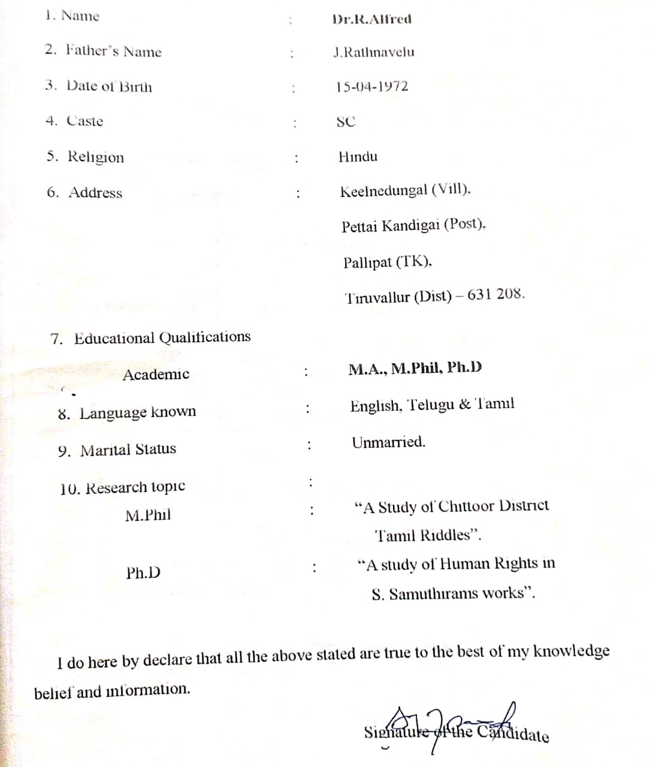

33. Student Achievements

34. SWOC analysis

35. Report

36. Future Plans

### எனது எதிர்கால திட்டம்

நான் எனது பள்ளிப்படிப்பை முடிக்கவிருக்கும் நிலையில் எனது எதிர்காலம் குறித்து அடிக்கடி யோசிப்பேன். என் மனதில் பல கேள்விகள் உள்ளன, நான் எந்தத் தொழிலைத் தேர்வு செய்ய வேண்டும் என்பதுதான் பெரும்பாலும் என் மனதைச் சுற்றி வருகிறது. ஒரு தேர்வு செய்வது எனக்கு கடினமாக உள்ளது, ஏனென்றால் அந்த முடிவு எனது முழு வாழ்க்கையையும் பாதிக்கும் என்பதை நான் அறிவேன். நான் அனுபவிக்கக்கூடிய ஒரு தொழிலை நான் எப்போதும் கனவு காண்கிறேன், அது எனக்கு சவாலைக் கொண்டுவருகிறது மற்றும் என்னை திருப்திப்படுத்துகிறது. எனக்கு ஒரு பொழுதுபோக்காக இருக்கும் வேலையை நான் நம்புகிறேன். பணம் சம்பாதிப்பதற்காக நான் வேலையைச் செய்ய விரும்பவில்லை. மாறாக, எனது தொழிலையும் கடமையையும் நேசிக்க விரும்புகிறேன். மேலும், எனது பணி சமுதாயத்திற்கு பங்களிக்கும் வகையிலும், மக்களுக்கு உதவும் வகையிலும் இருக்க வேண்டும்.